**ENGLISH FIRST ADDITIONAL LANGUAGE**

**GRADE 12**

**2010**

**COMPREHENSION TEST**

*Travels With My Aunt*

1. *I* was weeding the dahlias, the Polar Beauties and the Golden Leaders and the Requiems, when my telephone began to ring. Being unused to the sound which shattered all the peace of my little garden, I assumed that it was the wrong number. I had very few friends, although before my retirement I boasted a great many acquaintances. There were clients who had stayed with me for twenty years, who had known me in the same branch as clerk, cashier and manager, and yet they remained acquaintances. It is rare for a manager to be promoted from the staff of a branch in which he will have to exercise authority, but there were special circumstances in my case. I had been acting manager for nearly a year owing to my predecessor's illness, and one of my clients was a very important depositor who had taken a fancy to me. He threatened to remove his custom if I did not remain in charge. His name was Sir Alfred Keene: he had made a fortune in cement and my father, having been a builder, gave us an interest in common. He would invite me to dinner at least three times a year and he always consulted me on his investments, though he never took my advice. He said it helped him to make up his mind. He had an unmarried daughter called Barbara who was interested in tatting, which I think she must have given to the church bazaar. She was always very kind to me, and my mother suggested I might pay her attention, for she would certainly inherit Sir Alfred's money, but the motive seemed to me a dishonest one and in my case I have never been greatly interested in women.. The bank was then my whole life, and now there were my dahlias.

2. Unfortunately Sir Alfred died a little before my retirement, and Miss Keene went to South Africa to live. I was intimately concerned, of course, with ail her currency difficulties: it was I who wrote to the Bank of England for this permit or that and reminded them constantly that I had received no reply to my letters of the 9th July; and on her last night in England, before she caught her boat at Southampton, she asked me to dinner. It was a sad occasion without Sir Alfred, who had been a very jovial man, laughing immoderately even at his own jokes. Miss Keene asked me to look after the drinks and I chose an Amontiliado, and for dinner Sir Alfred's favourite Chambertin. The house was one of those big Southwood mansions surrounded by rhododendron bushes which dripped that night with the steady, slow November rain. There was an oil painting of a fishing boat in a storm after Van de Velde over Sir Alfred's place at the diningroom table, and I expressed the hope that Miss Keene's voyage would be less turbulent.

(Graham Greene: *Travels With My Aunt)*

**MULTIPLE CHOICE QUESTONS: NUMBER TWO Circle the correct answer.**

1. The narrator is a retired

(a) horticulturist

(b) minister

(c) banker

2. When the narrator heard the telephone ringing he assumed

(a) it was one of his clients

(b) it was a wrong number

(c) it was one of his many friends

3. The narrator occupies himself in his retirement

(a) with business friends

(b) with Barbara Keene

(c) with his dahlias

4. Sir Alfred Keene and the narrator shared a common interest

(a) in banking

(b) in building

(c) in gardening

5. Barbara Keene was obviously

(a) a good cook

(b) interested in dahlias

(c) interested in homecrafts

6. Sir Alfred Keene

(a) saw a great deal of the narrator

(b) saw the narrator on a few occasions

(c) never saw the narrator

7. The narrator's mother encouraged his friendship with Barbara Keene

(a) because of her artistic talent

(b) because of her future wealth

(c) because she was kind to him

8. Sir Alfred Keene

(a) made his own financial decisions

(b) valued the narrator's advice

(c) never made an investment without consulting the narrator

9. When Sir Alfred Keene died the narrator

(a) had retired

(b) helped the daughter with various financial matters

(c) went to South Africa

10. Sir Alfred Keene had been

(a) very boring company

(b) extremely pleasant company

(c) a recluse

Check your answers on page 39.

**TEST 2 Question 2**

The following comprehension questions are based on excerpt number TWO. You will need to refer to the passage to answer the questions. Write in the spaces next to the answers.

1. The following words appear in the comprehension passage. Select a word or phrase from the list below, which is similar in meaning to:

(a) assumed (par. 1)

(b) acquaintances (par. 1)

(c) predecessor(par. 1)

(d) motive (par. 1)

(e) immoderately (par. 2)

**Words and phrases:**

intention, realised, former holder of position, knew, guessed, unashamedly, people  
known casually, excessively. [5]

2. Give the part of speech of the words in bold in the following phrases:

(a) to exercise **authority** (par. 1)

**(b) acting** manager (par. 1)

(c) always **consulted** me (par, 1) [3]

3. Give antonyms for:

(a) rare (par. 1)

(b) interested (par. 1)

(c) turbulent (par. 2) [3]

4. "The writer does not tell us that he was uninterested in women."

Is this statement TRUE or FALSE? [1]

5. One species of the writer's dahlias was named the "Requiem" (par. 1). What is the more usual meaning of this word?

(a) a collection of Latin scripts

(b) a mass song for those who have died

(c) a chant sung by a church choir [1]

6. "One of my clients...had taken a fancy to me." (par. 1) Does this mean

(a) the client offered the writer a gift

(b) the client fancied the writer liked him

(c) the client liked the writer [1]

7. Are "currency difficulties" (par. 2)

(a) exchange rates

(b) money problems

(c) current problems [1]

**Total:** 15 **marks**

**SECTION B – SUMMARY**

Read the following passage and answer the question that follow:

**Feeling inadequate**

You’re not alone. Charnica Huggins discovered that it’s not just women who obsess about their bodies. Take note the next time your man picks up a magazine…

Men are catching up to women in one area. They too are feeling pressure to achieve perfect bodies and this can lead them down unhealthy paths. The finding of a new study “challenge the myth that men aren’t affected by the media or others’ comments towards their bodies”, says Dr Tracy Tylka of Ohio State University.

In the light of such research, Tylka investigated the relationship between the pressure to become more muscular and men’s adoption of certain behaviours. For her study, 285 American university males completed various surveys about the pressure to be muscular and its ramifications. On a scale that ranged from “never” to “always”, the study participants reported that they “often” felt pressure to be muscular, according to Tylka. They “often” or “usually” internalised the muscular images presented by the media – they believed that the only desirable shape is the highly muscular body type. They were also “often” or “usually” dissatisfied about their bodies. The men also reported that they “sometimes” engaged in maladaptive behaviours, Tylka reports.

Men who were dissatisfied with their muscularity, for example, were likely to be more preoccupied about becoming more muscular, which led to their use of supplements, and possibly steroid use, to achieve that muscular image, according to Tylka. Dissatisfaction with their level of body fat predicted a higher preoccupation with counting calories and cutting out certain food groups. Because their idealised muscular body image is rooted in society, with “men thinking they’re expected to look a certain way, it can contribute to very negative things for men,” Tylka says.

“Instead of pressurising men to be more muscular, accept men’s bodies for what they are, and focus on internal characteristics,” she says.

**Question**

The above text examines the effects of men being pressurised by the media. Read this article carefully, then write a point-form summary in which you discuss the consequences of these articles on male audiences. Write down five (5) facts. Do not write more than 60 words. Write short but complete sentences. Indicate the number of words you have used.

(7)

**Section C – Visual literacy**

Read the following cartoon and answer the questions that follow:

3.1 What does the C in frame 1 represent?

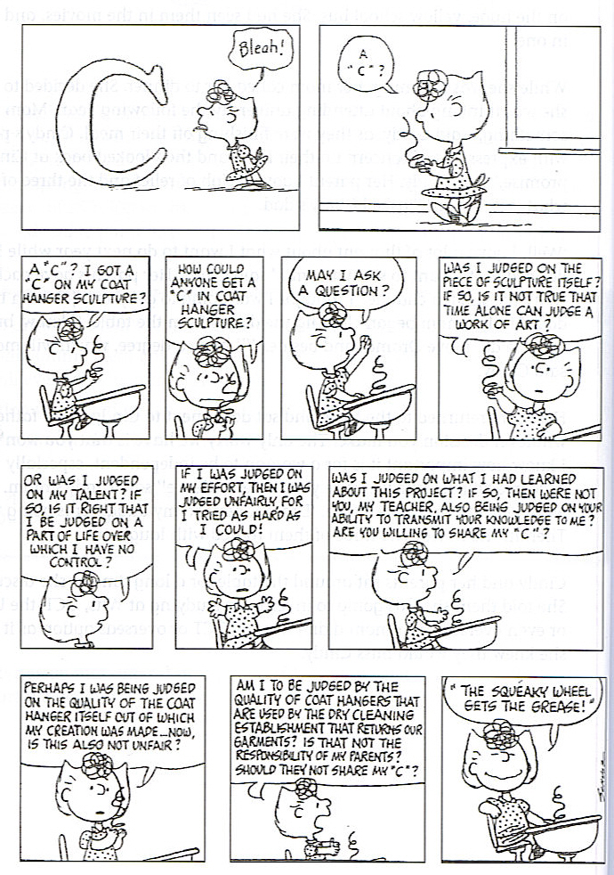

(1)

3.2 How does the character feel about the C in frame 1? Give a reason for your answer.

(2)

3.3 Why should the character not be judged on effort?

(1)

3.4 Why does the character offer so many arguments to the teacher?

(1)

3.5 Choose the correct synonym for “judged” from the three choices given: mediated, refereed, assessed

(1)

3.6 What do you think is the meaning of the expresson “the squeaky wheel gets the grease!”?

(2)

(8)

4. Read the following passage below and answer the questions which follow:

1. One’s level of happiness depends simply on the number and nature of the pleasurable events which happens to you. 2. Of course, its indisputable that the number and nature of the pleasurable events you experience play a part in determining how happy you are; 3 however, their importance is generally grossly exaggerated. 4. Pleasurable events may enhance happiness at the time of their occurance, but their effects on the level of happiness tend to often be transient. 5. Highly pleasurable events, compared and viewed alongside moderately pleasurable ones, can make the latter seem uninteresting. 6. Hoping to live on a “high” all the time, pleasurable events can become our only goal. 7. There is more to life than us being happy all the time.
   1. Look at sentence 1. Correct the error in CONCORD in the sentence.

(1)

4.2 Look at sentence 2. Correct the error in this sentence by rewriting the corrected word only.

(1)

4.3 Look at sentence 3. Why is “however” not written with a CAPITAL LETTER?

(1)

4.4 Look at sentence 4. Correct the SPELLING error in the sentence.

(1)

[4]

5.1 Change the following sentence into the NEGATIVE form: I feel like a struggling swimmer in a raging current.

(2)

5.2 Write the following sentence into indirect speech beginning with Neil said:….

I am a very happy person today.

(3)

5.3 Change the following sentence into a question: She loves her dog.

(1)

[6]

Total: 40÷2=20